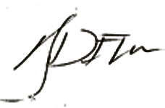IGG. YDAYLE N. DEL ROSARIO
Punong Barangay

BARANGAY CLEARANCE

TO WHOM IT MAY CONCERN:

This is to certify that the person whose name, signature, thumb marks and other personal data appearing hereon, has requested for a Barangay Clearance from this Office and the results are listed below.

NAME :
ADDRESS :
DATE OF BIRTH:
PLACE OF BIRTH:
PURPOSE :

This is to further certify that is a bonafide resident of this Barangay. is known to me with a good moral character, law abiding citizen in the community. has no criminal Record found in our Barangay Records.

Given this
Valid until:

CTC NO. :
ISSUED AT :
ISSUED ON :
O.R. NO. :
PREPARED BY :




RIGHT
THUMB
MARK
LEFT
THUMB
MARK
______________________________Signature of Applicant

